**LAB ASSIGNMENT – 9**

Grihit Budhiraja

19BCE2141

**Simulation of Switch**

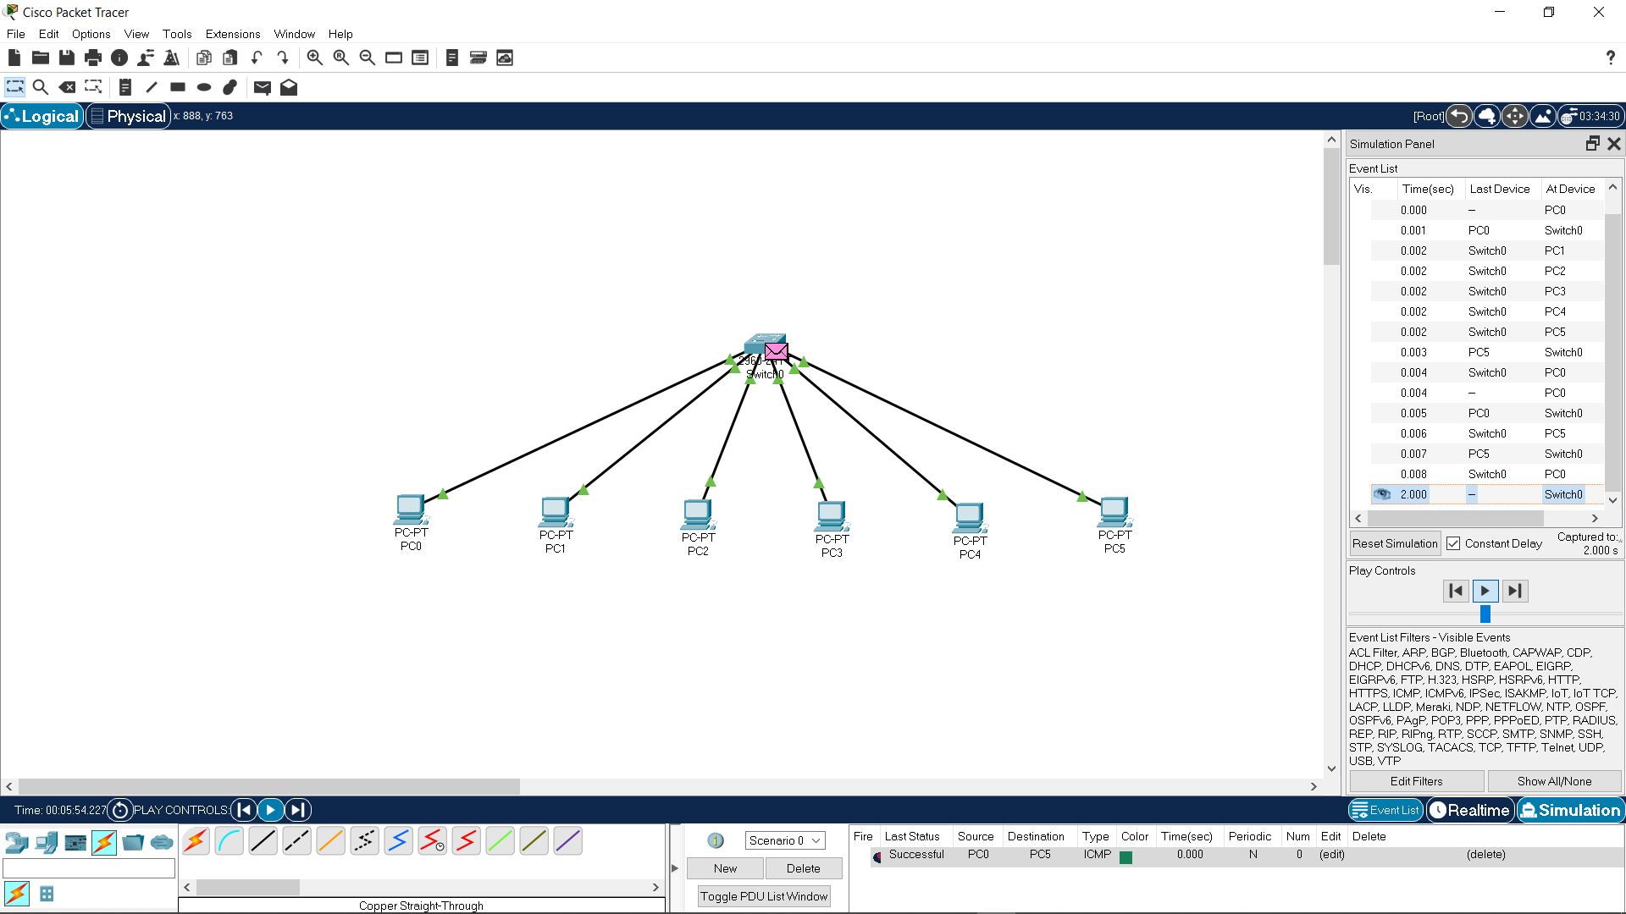

**Simulation of Hub**

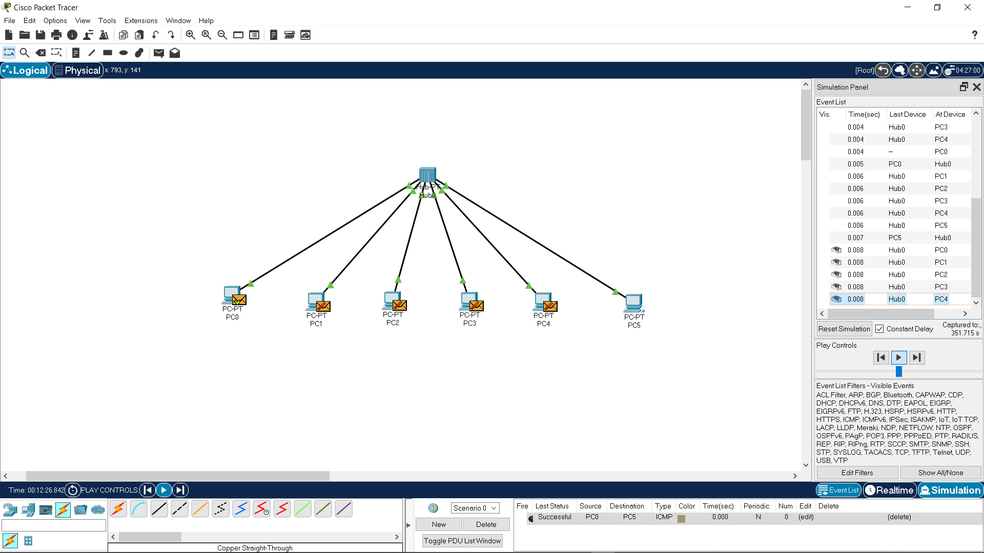

**Simulation of Router**

